**Daily Scrum or Standup Meeting**

Team name: 5th Element

Scrum Master: Leonardo Craven

Date: October 22, 2021

| **Team Member** | **What did you do since the last scrum?** | **What do you plan to do before the next scrum?** | **What obstacles do you have?** |
| --- | --- | --- | --- |
| Leo | Added page to view and register for tournaments | Add CSS to this page, implement page for sponsors to request tournaments | None |
| Gavin | Added page to create tournaments | Add CSS to this page, implement page for managers to approve/deny sponsor requests | None |
| Andrew | Redesigned home page with CSS and dynamic generation based on user type | Add page for sponsors to sponsor existing tournaments | None |
| Brock  (not present at meeting) |  |  |  |
|  |  |  |  |

# Burndown

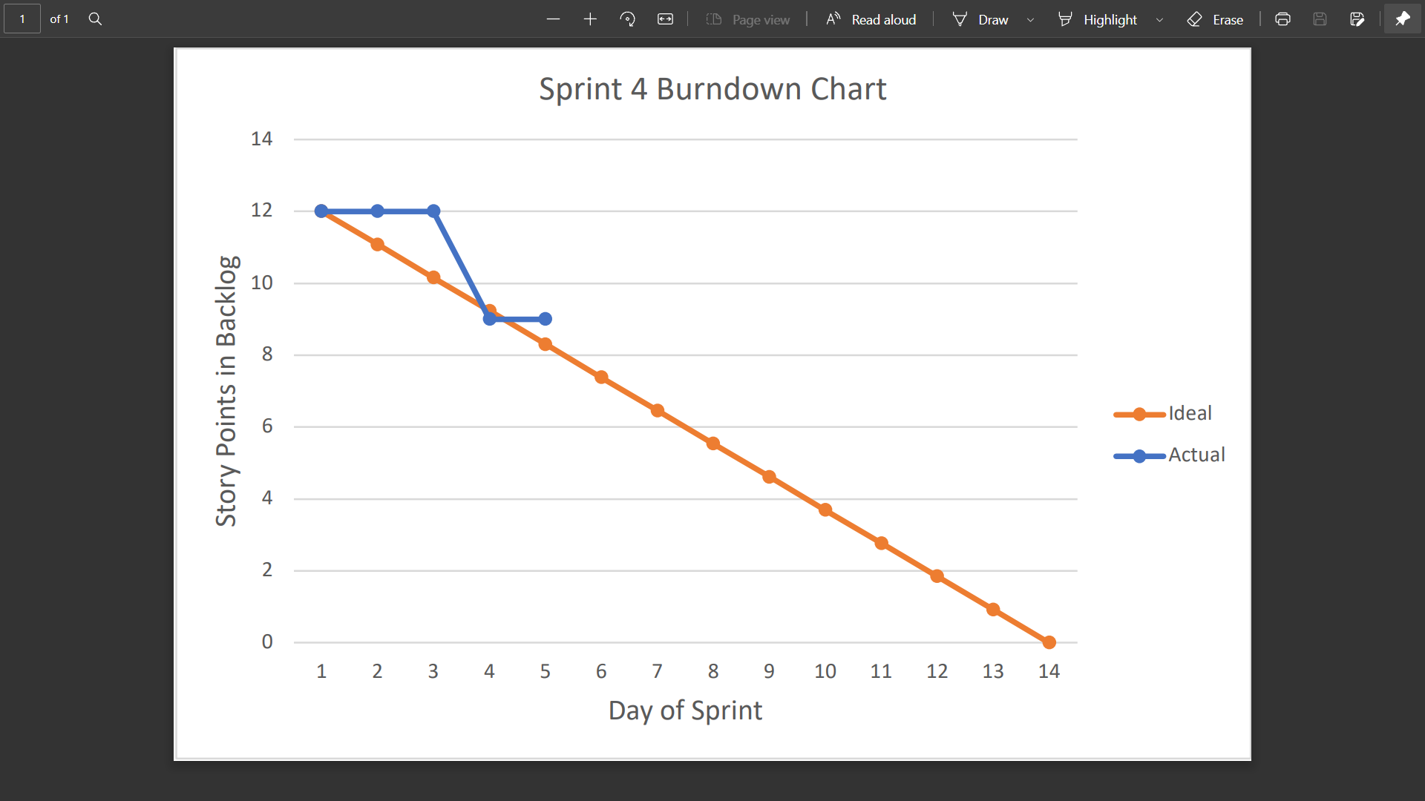

# Screenshot of you project board

